

Blue Shield Founding Conference
7th, 8th and 9th of December 2008
The Hague, The Netherlands

Invitation

Oslo/Amsterdam 30 September 2008

The Founding Conference of the Association of National Committees of the Blue Shield (ANCBS) will be held in The Hague on the 7th, 8th and 9th of December 2008 and you are cordially invited to participate. As this is the Founding Conference, we hope to welcome representatives of many like-minded or related organizations.

The Founding Conference will have a threefold agenda:
First day (Sunday 7th): The formal founding of the ANCBS, including the Statutes, the Strategic Plan and the election of the Board.
Second day (Monday 8th): Strengthening the network between Blue Shield and other cultural emergency assistance organizations, institutions and authorities: ANCBS will present its plans for the coming years. National Blue Shield committees present their progress reports and there will be presentations on recent emergency situations and emergency response actions.
Third day (Tuesday 9th): Improving the knowledge and skills of the conference participants during training courses and workshops that will benefit from the wide range of experience of the participants. This day will give everybody the opportunity to become more effective in meeting requests for help with adequate responses.

Participants:
First day (Session of Blue Shield members): Members of all Blue Shield committees, (established committees and committees under construction). All members of the ICBS board and members of the international working group. Observers are welcome.
Second and third day: Representatives of likeminded or related cultural heritage organizations. Members of Blue Shield committees (established committees and committees under construction) and members of the ICBS.

Background:
The plan to form an Association of National Committees of the Blue Shield was discussed at the first Blue Shield meeting in Torino 2004. At the second meeting in The Hague 2006 an international working group was elected which has since made preparations for the new association. The working group approached the City of The Hague, which has generously provided office space and three years of financial support to establish an ANCBS coordination centre in The Hague. With these tools, the time has now come to formally establish the ANCBS.

Practicalities and money:
The conference will take place at The Royal Library and the National Archive in The Hague. The office staff can help you to make reservations at nearby hotels at moderate rates. Participants are asked for a Conference fee of 50 Euro per day for the 8th and 9th of December, payable in cash at registration.
Updated information will be available at http://infocenter2.ancbs.org

We would appreciate your help in distributing this invitation to individuals and institutions that are interested in or should be aware of the Blue Shield mission.

You are kindly requested to respond before the 18th of November. You can answer either by post to the address below or by e-mail to contact@ancbs.org We look forward to seeing many of you in The Hague in December during the conference, which we think will be an important step in the effort to provide coordinated help to endangered cultural heritage worldwide.

On behalf of the ANCBS Working group,
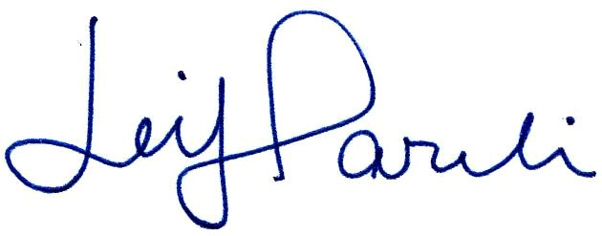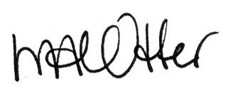

Leif Pareli, Chairman Marjan Otter, Secretary
www.blueshield.no www.blueshield.nl
(Blue Shield Norway) (Blue Shield Netherlands)

Postal address:
ANCBS Office,
Laan van Meerdervoort 70
2517 AN The Hague,
The Netherlands

