ICOMOS  International Cultural Tourism Committee  Membership Application Form  Expert Member Category  September 2007 | 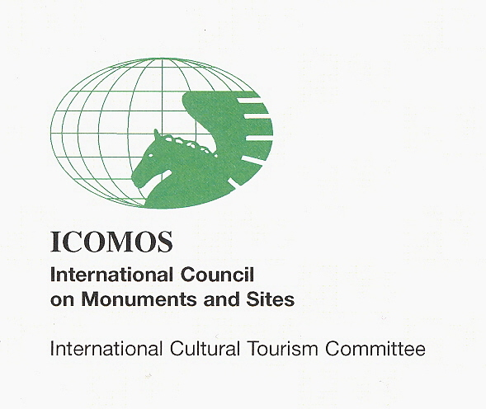

Introduction

The Statutes of the ICOMOS International Cultural Tourism Committee (June 2007) stipulate that there are four categories of ICTC membership:

- Expert Members
- Associate Members
- Institutional Members
- Honorary Members

ICTC Expert Members are expected to engage in a variety of appropriate voluntary, sponsored or fee paying activities, both internationally and in their own region, that contribute to the achievement of the ICTC Mission and Objectives.

All Expert Members shall have the right to vote on all formal matters before the Committee, with the exception of the election of ICTC Office Bearers and amendments to the ICTC Statutes. Voting for the election of ICTC Bureau members and for amendments to the ICTC Statutes shall be restricted to those Expert Members who have been nominated by ICOMOS National Committees, which members are restricted to one per state. There is no charge for ICTC Expert Membership.

There shall be no numerical, national or geographic limit to any of the membership categories.

The membership of any ICTC member may be terminated at the discretion of the ICTC Bureau members, provided that the decision is confirmed by a majority vote of existing Expert Members.

ICTC Expert Membership Criteria

Individuals wishing to nominate or be nominated for Expert Membership of the ICOMOS International Cultural Tourism Committee must satisfy the following criteria.

- Are members of ICOMOS or of a National Committee of ICOMOS, and

- Have a professional commitment to the ICTC Mission and Objectives in addition to the Principles of the ICOMOS International Cultural Tourism Charter, and

- Demonstrate a willingness to actively participate in ICTC activities, and

- Have a reasonable degree of professional expertise or experience in the issues surrounding the sound management of tourism activities at heritage places, or

- Have sufficient educational training in the issues surrounding the sound management of tourism activities at heritage places.

Expert Members may use the title “Expert Member, ICOMOS International Cultural Tourism Committee” and may identify their ICTC membership in support of their professional activities.
Mission

The Mission of ICTC is to promote the responsible management of sustainable tourism activities at natural and cultural heritage places and sites, including historic towns, cultural landscapes, archaeological sites, galleries, museums, moveable and intangible heritage associated with heritage sites to better protect the heritage values and communicate those values to the host community, visitors and other relevant stakeholders.

Objectives

To fulfil its Mission ICTC shall pursue a number of Objectives:

- To promote the widest possible understanding of the importance of responsible tourism and sustainable management practices for tourism activities at natural and cultural heritage places and sites, including historic towns, cultural landscapes, archaeological sites, galleries and museums, moveable and intangible heritage associated with heritage sites.

- To promote the concept that one of the most important reasons for undertaking any form of conservation is to make the significance of the place accessible to the host community and visitors, in an honest and well managed manner, and without adversely impacting on its authentic heritage values.

- To promote the concept that the host community, conservation practitioners and the tourism industry must cooperate and work together to protect and present the world’s natural and cultural heritage, recognising their mutual respect for the heritage and its fragility in the face of tourism activity.

- To assist ICOMOS accomplish its role in the context of international conventions (especially the World Heritage Convention) and in its cooperation with UNESCO and other relevant International Organizations, and be willing to receive mandates from the ICOMOS Scientific Committee to that effect.

- To carry out, facilitate and encourage specialized studies and promote the application of professional expertise and best practice standards in regard to the Committee’s Mission.

- To actively pursue cooperation within ICOMOS and the ICOMOS Scientific Council and with relevant national and international agencies and organizations with regard to the Committee’s Mission.

- To encourage multi-disciplinary and multi-stakeholder approaches to achieve best practice standards in the management of tourism in heritage places and sites.

- To encourage and participate in the exchange of experience and expertise in the on-going development of sound management and sustainable practices for tourism activities at natural and cultural heritage places and sites.

- To promote the importance of all forms of education and information as a means of achieving the other ICTC Objectives, especially among young people and those involved in the fields of conservation and tourism.

- To recognise the important stakeholder role of local residents, host communities, property owners and site managers in the local management of conservation, tourism activities and development.

Principles of the ICOMOS International Cultural Tourism Charter

Principle 1: Encourage Public Awareness of Heritage
Since domestic and international tourism is among the foremost vehicles for cultural exchange, conservation should provide responsible and well managed opportunities for members of the host community and visitors to experience and understand that community’s heritage and culture at first hand.

Principle 2: Manage the Dynamic Relationship
The relationship between Heritage Places and Tourism is dynamic and may involve conflicting values. It should be managed in a sustainable way for present and future generations.

Principle 3: Ensure a Worthwhile Visitor Experience
Conservation and Tourism Planning for Heritage Places should ensure that the Visitor Experience will be worthwhile, satisfying and enjoyable.

Principle 4: Involve Host And Indigenous Communities
Host communities and indigenous peoples should be involved in planning for conservation and tourism.

Principle 5: Provide Benefit for the Local community
Tourism and conservation activities should benefit the host community.

Principle 6: Responsible Promotion Programmes
Tourism promotion programmes should protect and enhance Natural and Cultural Heritage characteristics.

Expert Membership Application Declaration

I ……………………………………………………..……………….

Hereby confirm that I meet the following criteria for Expert Membership of the ICOMOS ICTC.

- I am a member of ICOMOS or of a National Committee of ICOMOS

- I have been endorsed by the ................................... committee of ICOMOS as its voting member of the ICTC

- I have a professional commitment to the ICTC Mission and Objectives

- I have a professional commitment to the Principles of the ICOMOS International Cultural Tourism Charter

- I am willing to actively participate in ICTC activities

- I have a reasonable degree of professional expertise or experience in the issues surrounding the sound management of tourism activities at heritage places, and/or

- I have sufficient educational training in the issues surrounding the sound management of tourism activities at heritage places.

I have signed this Application Form and completed the Member Profile, and returned it to:

Murray Brown
ICTC Membership Secretary
Email: brownmnsw@netscape.net
Fax: 61 2 9299 8711

Signed:

……………………………………………………………………………..

Date: ................................................... 2007
ICOMOS Cultural Tourism Committee
Member Profile
[No more than 2 pages]

Family Name

Given Name

ICOMOS National Committee

Contact details

Email address (1)

Email address (2)

Postal address

Telephone (day)
(night)

Fax

Academic qualifications

Name, institution & date

Tourism-related studies

Cultural tourism related practical experience

National (maximum 50 words)

International (maximum 50 words)

Cultural tourism interests

From visitor perspective (maximum 30 words)

From host perspective (maximum 30 words)

